Open HEA Software User Guide

# Background

## The Integrated Database for African Policymakers(IDAPs)

The Household Economy Approach (HEA) is a proven methodology and data set for describing how a rural population gets access to the food they need – a Livelihoods dataset. IDAPs seeks to integrate livelihoods data with climate, hydrology, weather and crop data to provide an extended analytic dataset that will enable policymakers and researchers to better understand the vulnerabilities and risks that face such rural populations. For more information on HEA see the [Evidence for Development (EfD) website](http://www.efd.org/our-work/methods/).

#### The first phase of the project will deliver a globally-accessible and sharable database for collecting and analysing the HEA dataset that is at the heart of IDAPs.

## Software Overview

The Open Household Economy Approach (Open HEA or OHEA) component of IDAPs is an application that manages the data collected during an HEA baseline study. The software allows users to capture the results of HEA Community interviews to configure their study and then generates template spreadsheets in MS Excel format to capture the data collected in Wealth Group interviews. IDAPs eliminates the need for additional paper records e.g. maps. It also stores geographical coordinates and other project site details e.g. district, sub district, community, date of interview etc.

The modules of this program include Project, Community and Wealth Group categories that record information about the area of study e.g. assets and sources of income and types within a community and different wealth group. The application is designed to provide reports, charts and other information used by Government, NGOs and others that understand how communities in different social and economic circumstances get the food and cash they need; their assets; the opportunities open to them; the constraints they face; and the options open to them at times of crisis. The OHEA component of IDAPs will, in future phases of the project, be integrated with other components that will incorporate climate change information which is not currently included in socio-economy assessment tools.

All acronyms and abbreviations used in this document are introduced in full before being used. However, for completeness, they are summarised in Appendix A – Acronyms and Abbreviations. Because this software is intended for use by trained HEA practitioners, the terminology and concepts of HEA and Livelihoods measurement are used freely, without explanation. Full explanations are available at the EfD website linked above.

# A Walkthrough of OHEA

## Introduction to an OHEA Project

First, you will need a username and password, which you can get from the project directors if you are a researcher in a relevant discipline or if your organisation is an accredited user.

There are two different levels of credentials that a user of this software may have, practitioner user & administrative user, which have wider access to controlling the software as well as using it. All the features in this guide will accessible to a Practitioner User

*Administrator Users*: those who have authority to both view and change information within the database, for example defining the nutritional value of Crop types.

*Practitioner Users* who have permission to use the software, but not change any of the reference data.

### Logging in

We first start by clicking on the website <http://idaps.walker.ac.uk:8080/EFD_v2/m/SignIn>. This will give a view that requires to enter the User name and Password to access the OHEA Software

In the “Organization” drop-down, select “OHEA_Training”.

Enter your user name and Password then click the “Sign in” button

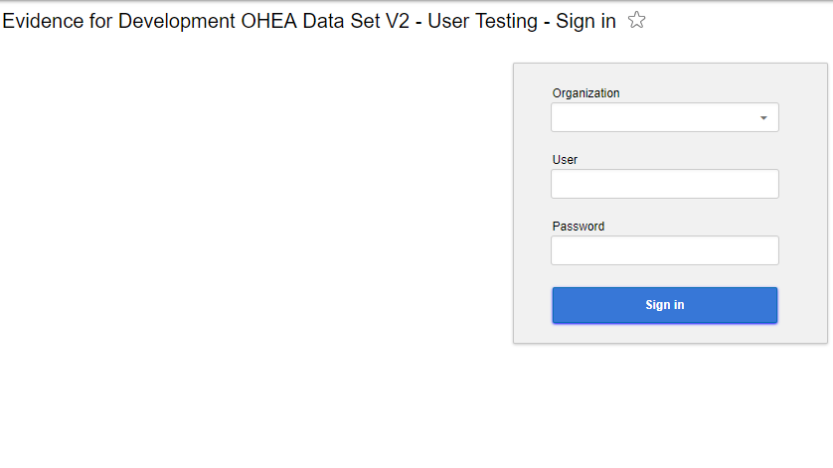

When you log in you normally see the screen you were looking at before you last logged out. The first time you log in you will see a page will appear with “Start” and “First steps” on the Menu.

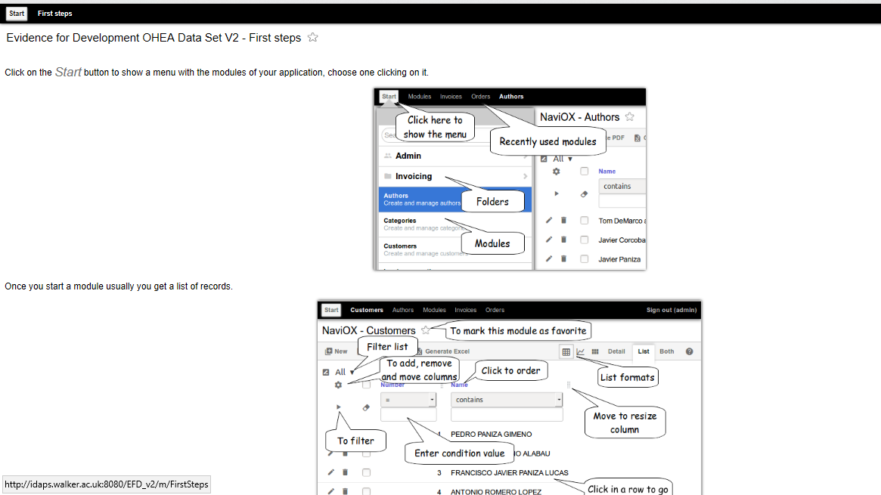

Click **Start**

When you Click on the Start button a menu with the modules will appear. You can search the module of your application that you want to use (Community, Project, Country etc.) in the “Search Modules” search box.

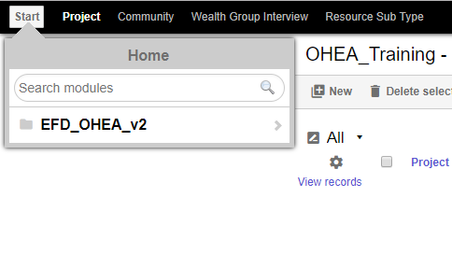

### Viewing a Project

Start to type “Project” in the Search Modules box; take a pause and it will find the “Project” module.

Select and click **Project**.

You will see a list of all Projects that are available to you; some of these will have been created by other users. It will look something like the screenshot below.

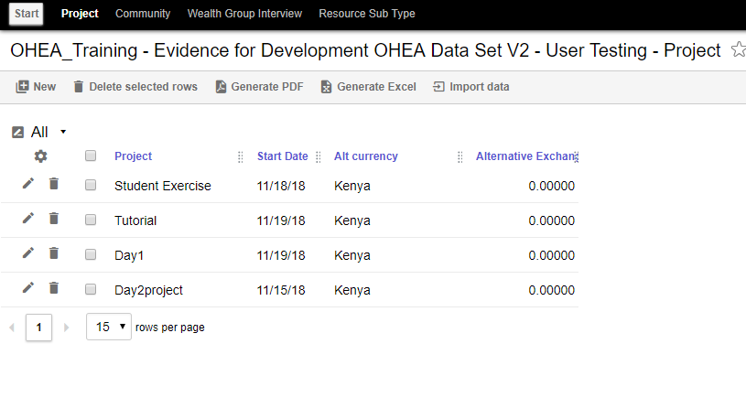

Each line is a project.

In HEA, a Project is typically the survey of a Livelihood Zone (LZ) at a number of Sites.

An LZ is an area of a country.

Click on the example project “Tutorial” in the list.

When you click on this project, you’ll see, amongst other details, the map of this LZ, in the Mukono of Uganda.

Hint: If you **don’t** see this project immediately, click on the word “Project” at the top of the list and it will sort the projects into alphabetic order. Note there may be more than one page of projects to dcroll through.

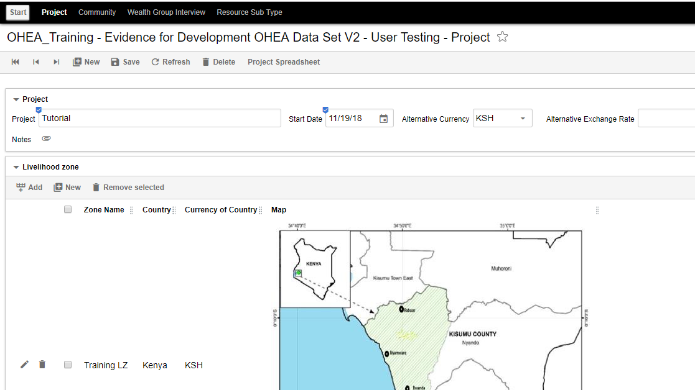

*Click the* ***pencil*** *symbol on the left of the screen, to edit existing information. This edit pencil symbol application applies to all modules.*

*There is no need to change any of the Livelihood Zone data right now so just click on the* ***Close*** *button to end the edit.*

*Click on the* ***List*** *tab in the top right of the screen to return to the list of Projects.*

Hint: “List” and “Detail” views are generally available on most modules. You can navigate between them using these tabs.

As we saw, clicking on a field of a row in the List view shows you the Detail view of that record.

### Examining the Communities in a Project

An HEA baseline study will visit a number of communities, each at a different site in the Livelihood Zone. At each Site (which is usually a village within the LZ) a number of interviews will be conducted with representatives of the Community that live there.

The detail of the first interview, called the Community interview, is recorded in the detail of a Community record.

Using the same steps that you used to search for the Project module, search for the Community module:

Click on the **Start** button in the top menu.

Start to type “Community” in the Search Modules box; take a pause it will find the “Community" module.

Click **Community** and you will see a list of all the Communities recorded, sorted by the Projects they are part of.

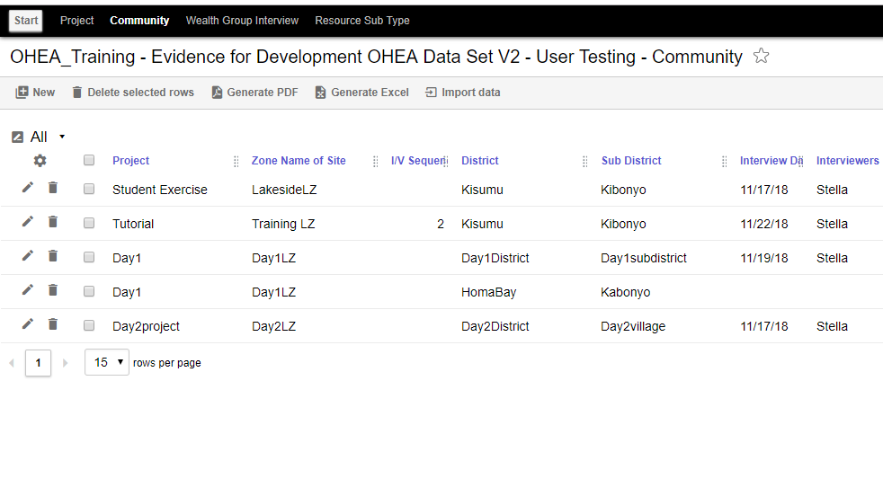

Click on the “Tutorial” project.

That is second in the list in the screenshot above.

it’s a Community in the project you looked at before - the Kisumu data set.

Hint: If you **don’t** see this project immediately, click on the word “Project” at the top of the list and it will sort the projects into alphabetic order. There may be more than one page of projects to page through.

The details of the Community will be displayed. 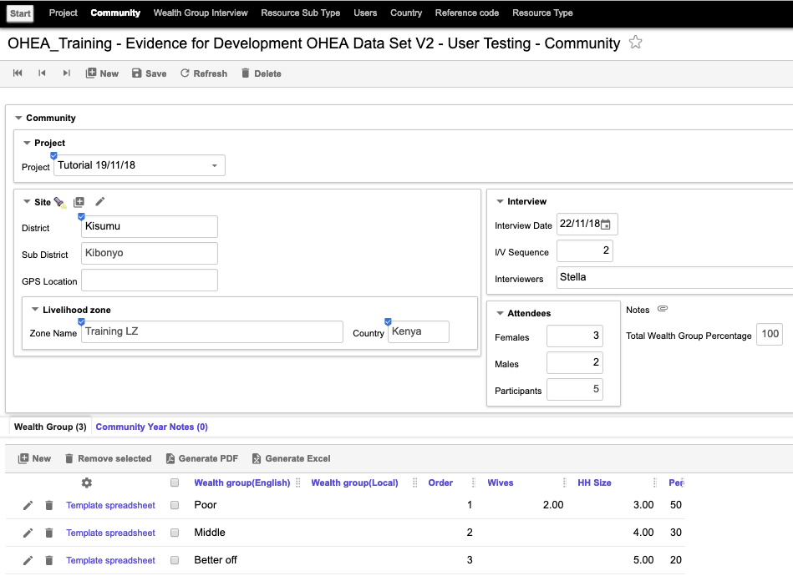

This shows the data collected in the Community interview at this Site.

It tells us something about the Survey (date etc., who did the interview, who was interviewed - at least numbers and genders of interviewees).

### The Wealth Groups

Further down this page the Wealth Groups (WGs) for the selected Community are shown. In this case “Poor”, “Middle” and “Better Off” - that's the typical 3, but sometimes there are more.

Click on one of the WGs to see a pop-up detailed record for that WG.

Hint: A click on the “Template spreadsheet” link in a WG record is a request to generate a template spreadsheet for the WG interview. These WG interviews have already been done and the data uploaded, as you will see later. OHEA does not allow you to generate another template for a WG interview, once that interview has been loaded, so if you click on that link now you will get an error message

The details include a list of the Characteristic Resources the community representatives might expect would be accessible by families in this WG.

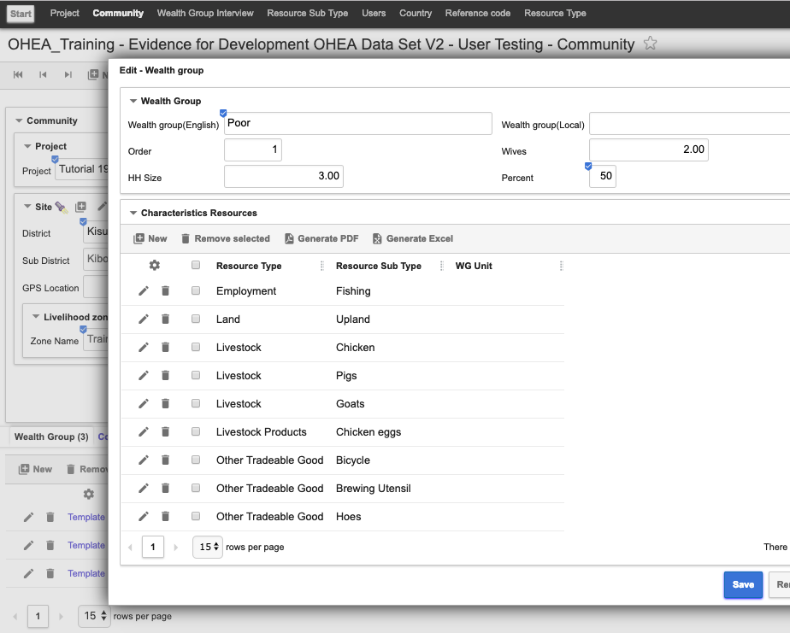

Click the **Close** button in the bottom right to return to the Community module.

### Recap

Note we’ve only looked at one Community, but the others would be comparable.

In an HEA study the next step, after the Community interviews, is to interview representative members of each WG. To do that the interview team typically, but not always, uses a template to collect their notes which they then transfer to a standard format spreadsheet. The template is to remind them the questions to ask. It is a checklist for the interviewer; it doesn’t constrain them.

### Generating the Wealth Group Interview spreadsheets

So, having read what this spreadsheet is for, let’s generate one:

The Detail view of the Community module shows all the Wealth Groups (WGs). You’ll see the words “Template spreadsheet” highlighted at the left of each WG row.

Click the first one (not on the “Template spreadsheet” link).

It will generate a spreadsheet into the default download folder for your browser. Its name will be Something like "NGombere_Coffee-Banana-Pigs_Poor.xls” – constructed from the WG, Village & LZ names, to ensure it’s unique. When you open the spreadsheet, it should look like this:

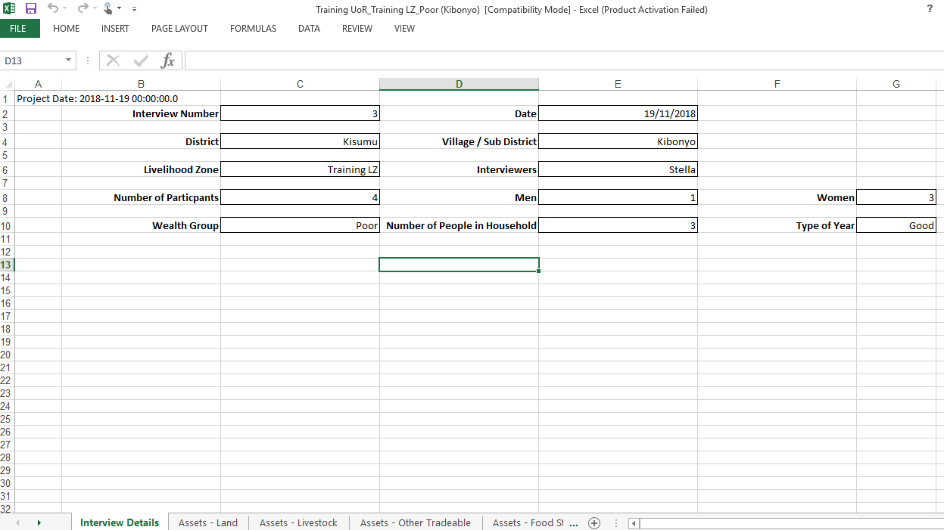

Hint: If the spreadsheet doesn’t generate, it may be that you have popups disabled in your browser. If this is the case, you need to configure your browser to allow OHEA to create popups. Alternatively, use a different browser that is already configured to allow pop-ups.

If you need help configuring your browser to allow popups, type “How do I configure xxxx to allow popups?” into the Google search engine, where xxxx is the name of the browser you are using – Safari, Firefox, Chrome etc.

You will see the various tabs, and you’ll see where the data will be collected in the interview.

This is the IDAPs OHEA standard spreadsheet layout. In the past people have used various variants. Going forward anyone using OHEA will have a standard spreadsheet.

# Summary

The software you have been using, OHEA, is the core HEA Livelihoods module of IDAPs. You have seen how the OHEA software works – modules, lists, detailed views, searching, etc. And you have explored how OHEA manages the data for the first part of an HEA project.

The next part of the project is loading interview data and creating the reports.   
These activities are introduced in the second part of the tutorial, the OHEA Mini-Project, which is interactive; in it you will create your own project rather than just navigating an existing data set as in this Walkthrough.

# Appendix A – Acronyms and Abbreviations

IDAPS Integrated Database for African Policymakers

OHEA Open Household Economy Approach

HEA Household Economy Approach

LZ Livelihood Zone

WG Wealth Group

EfD Evidence for Development